Leong Lau: Psychedelic Musician of East West Cultures
. . . | 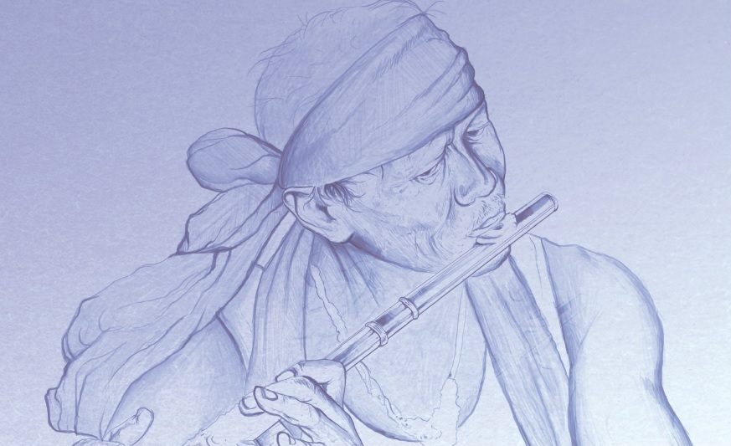  Leong's musicianship, philosophical, and visionary achievements are epitomized in the psychedelic album Dragon Man in which he communicates more profoundly than in any other work: love as universal responsibility and the integral person as the centre of community. Here, tragic conflicts among hippie heroes and heroines openly work out the abstract dialectical personalism of the Dragon and later, the Phoenix, in the next album called Rongeng Sound. Thanks to the passionate and precise and direct compositions, in music stanzas usually varying from seven to nine notes, the songs, much more substantially developed than most rock productions in the hippie era, express melodically without being disrespectful,. Hendrix, Clapton and Grateful Dead, to achieve transcendence through mysteries of psychedelic union and sacrificial rock riffs, which had enticed but eluded the polemics of blues and folk music and which Leong had played to ecstatic audiences in his raging concerts across Asia, Europe, USA and Australia in the 60s, 70s and 80s. 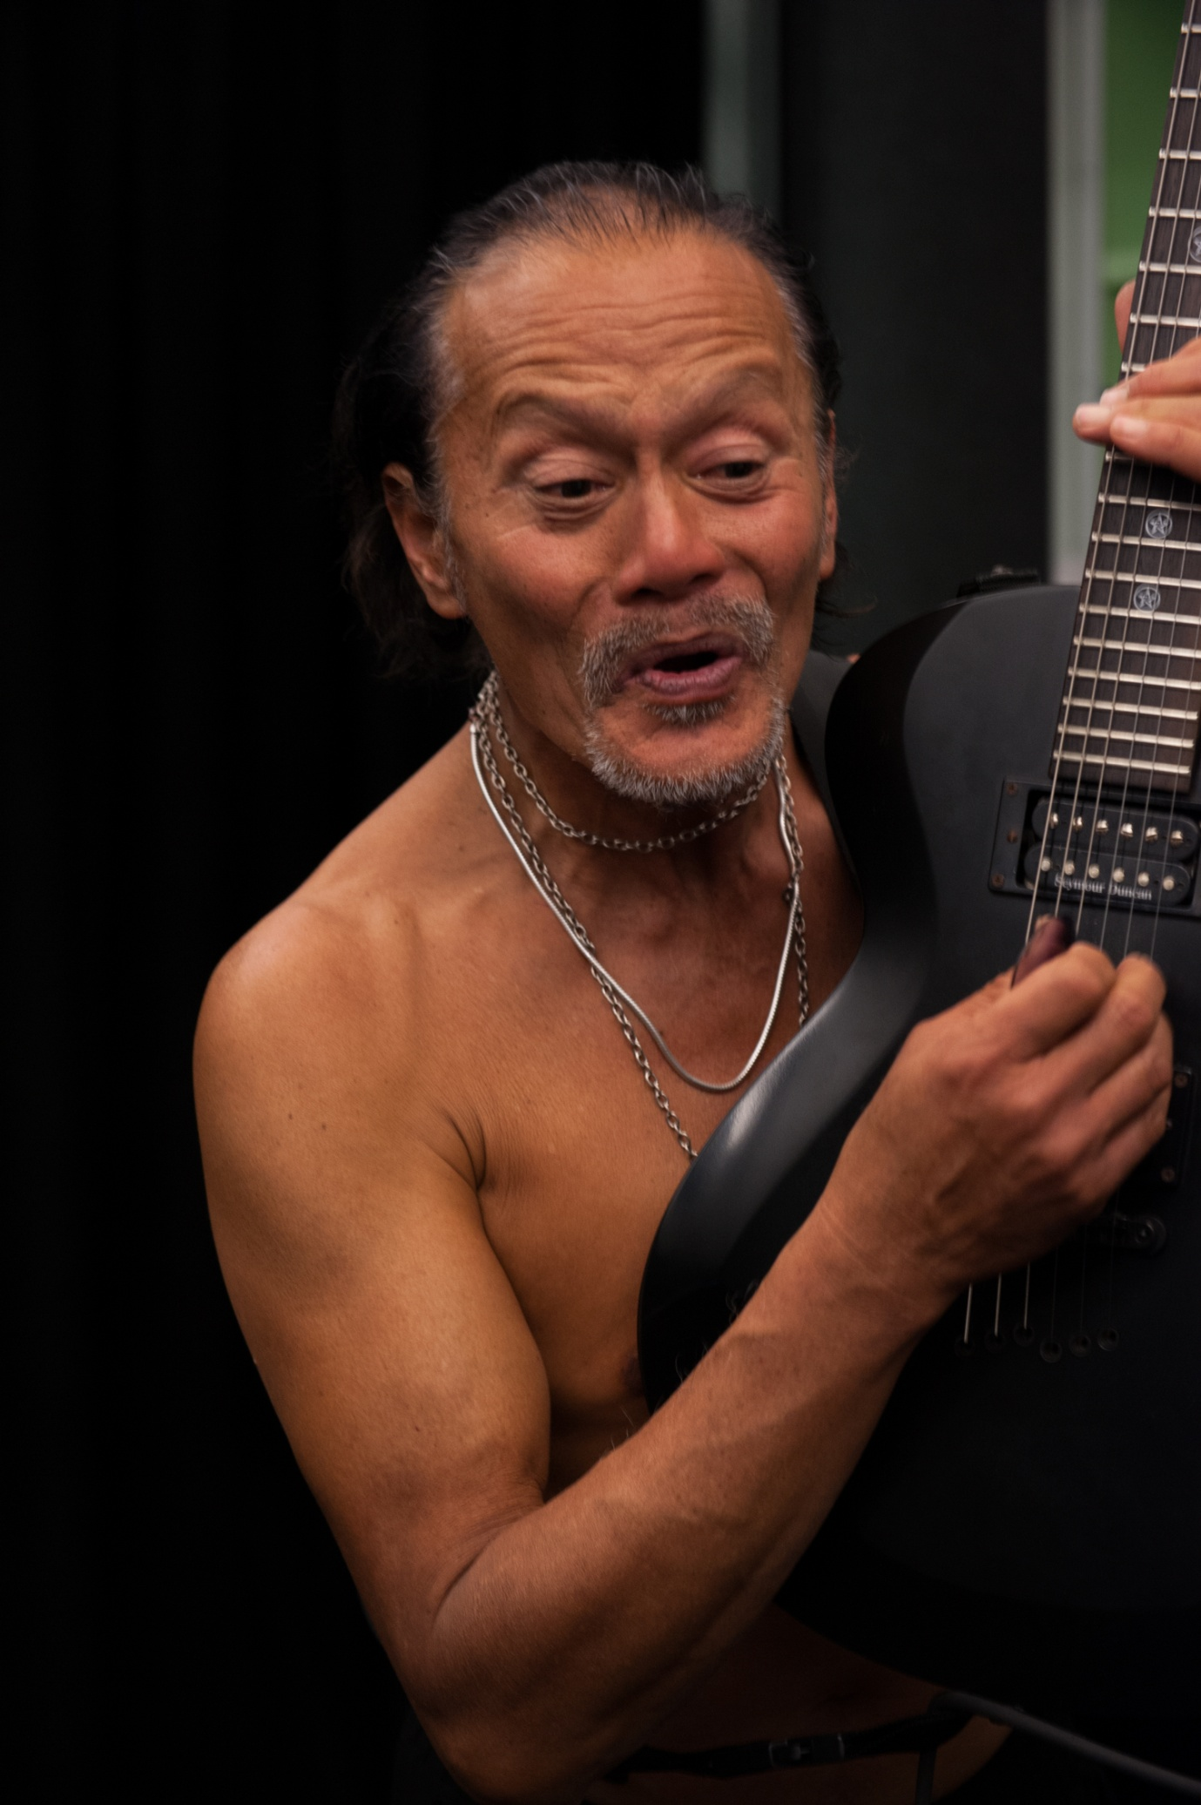  Leong acknowledged the influence of Chinese Opera and Shakespearean drama, the ritual verse-plays in which masked actors chant their lines, subtly gesture, and dance, but his playing in live performances resemble Iban jungle dances much more closely than the hippie performances, or by elusive and less logically structured Elizabethan plays or by Yeats' Plays for Dancers, which had given Leong early impressions when he was an engineering student sneaking into such “culture” at Newcastle University, NSW, Australia. . Leong's lyrics argue much more persistently and intellectually than do the more shadowy rock and folk songs  If Leong's music are more Asian than Western in form and ideas, they nevertheless reflect the Taoism of China explicitly and implicitly. The lyrics, including Ghost Drums bemoaning that War Gods ride unseen, repeat some of Lao Tzu’s last words, concerning the ephemerality of the world. The Tao’s universal balance of Yin/Yang is transformed into Deep in the Jungle's psychedelic riffs, allegorical to the hippie stereotypes going about their free love betraying Christian anxieties, that Sodom and Gomorrah will bring down the world  Tales of Brave Ulysses sung by Jack Bruce with Cream echoing adventures in verse suffering the wrath of Zeus, was a monumental performance, and in a similar manner, Leong creatively transforms intergalactic travel into a ''cobweb'' of infinite notes imagined between stars and mutually reflecting mirrors of the universe become infinite pairs of lovers whose eyes reflect each other’s hearts before euphoria is imaged in a climactic song, called Late Night Flyer from the Nature Rock Single.  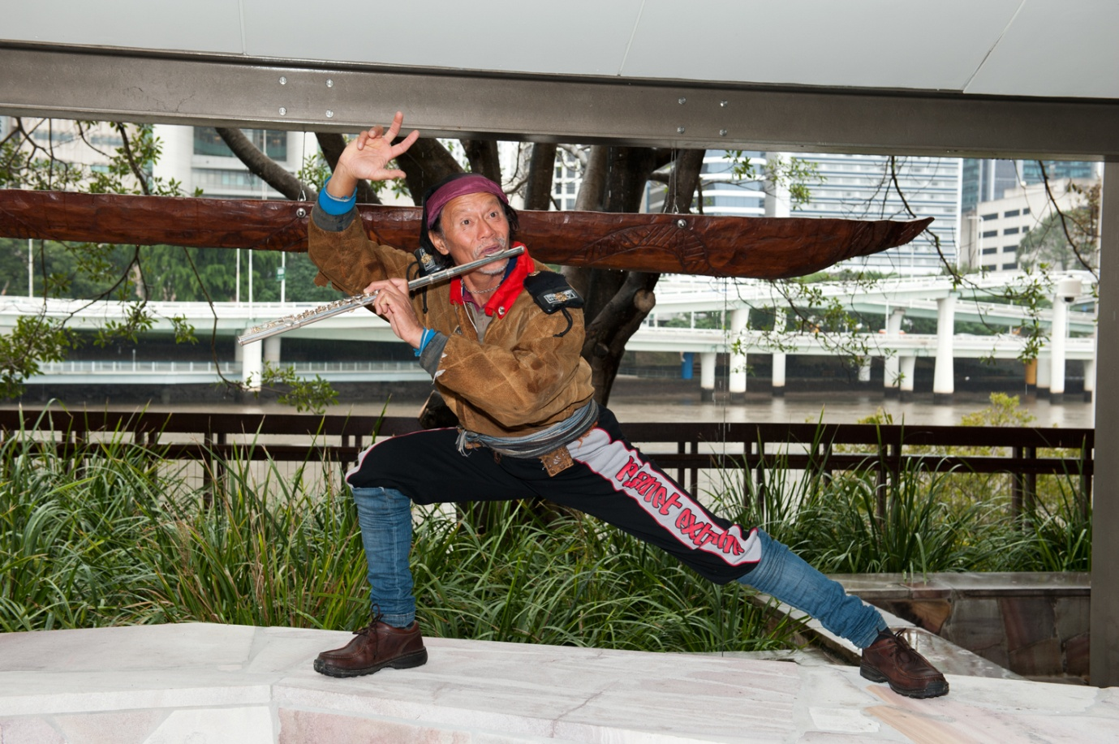  Some of Leong's song characters are derived from Euripides, but they are transformed with the kind of moral clarity that we associate more with Sophocles' heroes. In Classics Revisited, Leong distinguishes between Sophocles' tragedies of will and fate and Euripides' tragi-comedies in which egoists are trapped in confusion.4 In Leong's songs, cynical men of the world such as Demetrios, Theseus, and Agamemnon are treated as Euripides would have presented them, as mock-heroic parodies. Their motives are debased by their vulgarity, sentimentality, and callousness. On the other hand, Leong treats women of Artemis such as Iphigenia and Phaedra, and their lovers Achilles and Hippolytus, as Sophocles would have conceived them, ennobled by their suffering. Their fate is their responsibility, not the result of an external cause of catastrophe. In moral triumph and physical defeat they struggle with universalizing love, and their sacrifice renews community, through psychedelic insight.  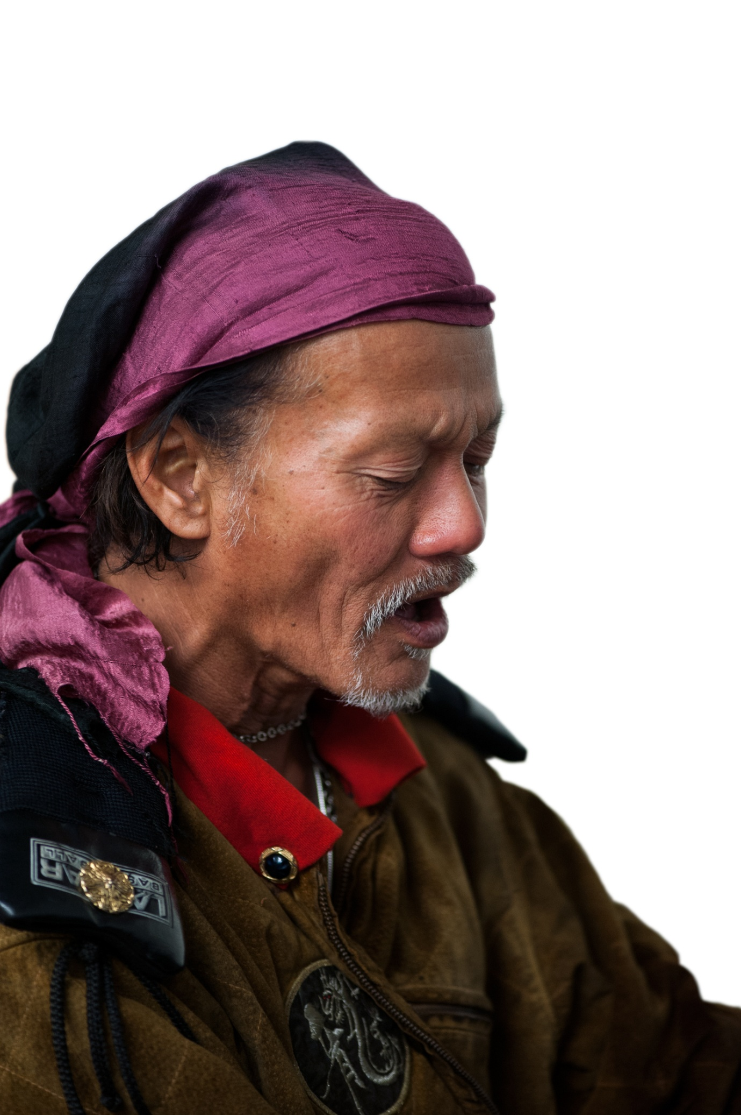  In Leong's songs one human type is the destructive man of the world, such as Theseus (who cynically lets Athens sicken while he visits Persephone in Hades), the usurper Demetrios, and Agamemnon (who sacrifices his daugher Iphigenia despite his knowledge that victory over Troy will not be worth the price). Transcending the unjust world, on the other hand, are certain women who worship Artemis. Iphigenia, the most saintly of all Leong's song characters, beyond dualities of cause and effect, will and purpose, persuades Agamemnon to sacrifice her to Artemis. Phaedra gives herself completely to the fires of creative process, but kills herself out of fear as well as responsibility. Tarakaia, whose compassion extends to mankind despite her violence, ranks higher on a scale of transcendence than Kalliope, who merely accepts guilt, or Berenike, who seduces Demetrios in order to kill him in vengeance.Male counterparts of the women of Artemis, inspired by them but less charismatic, try to detach themselves from the world like the Damascan brothers, but with varying digress of certainty. Torn between the human love of Phaedra and the divine love of the goddess, Hippolytus burns more brightly than Hermaios, whose good intentions are to make a good society rather than to transcend it; so he remains in the world of purpose. Achilles is guilt-ridden because of his consuming love for Iphigenia, and Menander tries to escape responsibility for the death of his mother. As in the polemics of ecstasy, Leong succinctly expresses this drama in Atlas Revolution.  Though motives are humanly impure, these men and women achieve various degrees of transcendence, some helping to create community in the face of depersonalizing forces, not only from Huns but from cynical Greek rulers as well. Depending on the purity of action, the integral person accepts responsibility. No act in the universe is explicitly Christian or Muslim, but universal compassion, love, responsible sacrifice, and utopianism are essential ingredients of both religions. Demetrios, Theseus, and Agamemnon still rule the world, and acts of sacrificial love in our warlike world still reflect the values of these plays and the spiritual traditions embodied in them. Dragon Man is Leong's most fully realized musical work. It should be understood and experienced not only as entertainment and musicianry but fundamentally as sacrament that renews our sense of integral persons as the source of true community, arising from mysterious processes of creation and destruction but ultimately transcending them. The flexibility of Leong's style perfectly generates a range of experiences as psychedelically, psychologically and as morally complex as their classical counterparts. Shall we strive for power or withdraw into the contemplative life? Is love salvation or deception? How can we be one with another, with humankind, with the universe? The answers come, if at all, not through reason, but through the music of Leong Lau: psychedelic musician, philosopher and visionary composer. | ....

