VISIONARY COMPOSER Leong Lau: Musician of East West cultures
. . . | "MUSIC COMPOSITION IS VISION" –  "VISION IS LOVE"  According to Leong's theory and practice, music composition is vision. Musicians and critics have often used this term carelessly, but in Leong's work "vision" has several definite meanings that cohere in his organic philosophy of music performance-in-the global community. 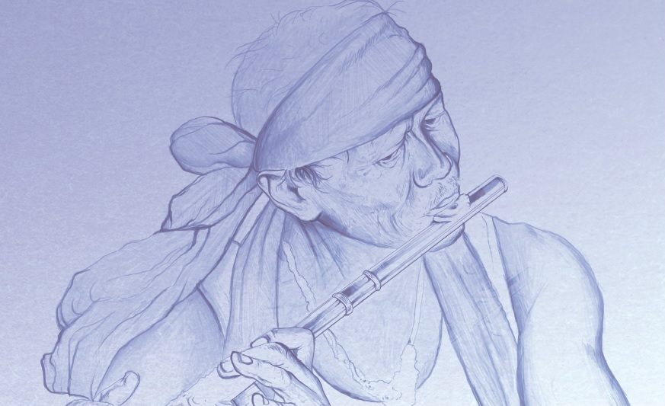  "Vision," referring to phases of a creative process of consciousness, sometimes means contemplation, in which the musician communed with nature and those he loved, and in which he periodically had oceanic, ecstatic experiences of realization, illumination, or enlightenment. At these times, sensation, perception, thinking, and feeling, especially love, were clarified, purified, and radically expanded; so he claimed that "vision is love." As experience became intellectualized, vision came to mean the act of philosophizing and also the world-view projected by philosophizing; so vision is both sensuous and abstract, non-verbal and literary, personal and transpersonal. Leong's world vision is both conservative in reviving and uniquely synthesizing Taoist-Christian, Classical, Hindu, and modern traditions of spiritual realization, and psychedelic in its vigorous denunciation of the prevailing impersonality, oppression, and alienation of modern society, technology, and culture, which he believed could be replace by a humane and enlightened way of life. As his personal experiences were expressed in music composition, vision became the act of music performance communication, evolving from interpersonal communion and recreating community. His vision is uniquely his, yet it is also universal in scope and validity because it realizes the person in world community. Leong's world vision reveals his, and our, "One Dimensional Man," as Herbert Marcuse puts it in his book also called “One Dimensional Man”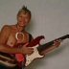.  "Music composition is vision," Leong asserts in music composition, which is regeneration, and complies with D. H. Lawrence’s view," "the pure act of sensual communion and contemplation." [2] Does he mean all music composition, or the best of it? Obviously his idea is normative rather than descriptive, characterizing the music composition akin to the literary works of Lawrence, Yeats, Blake, Whitman, the great achievements expressed in music composition that he translated from Tu Fu, Li Ch'ing Chao, Sappho, Dante, and his own. He means by "vision" the essence of music composition, the quality that makes it true music composition, the quality often ignored by critics who emphasize form, structure, construction, or technique at the expense of imagination, or identify artifice as music composition itself. Craftsmanship is important in Leong's own music composition and all music composition that he values, but as a means to an end rather than as an end in itself. What, in his opinion, does music composition at its best communicate? Visionary experience: vision itself. And what is that? 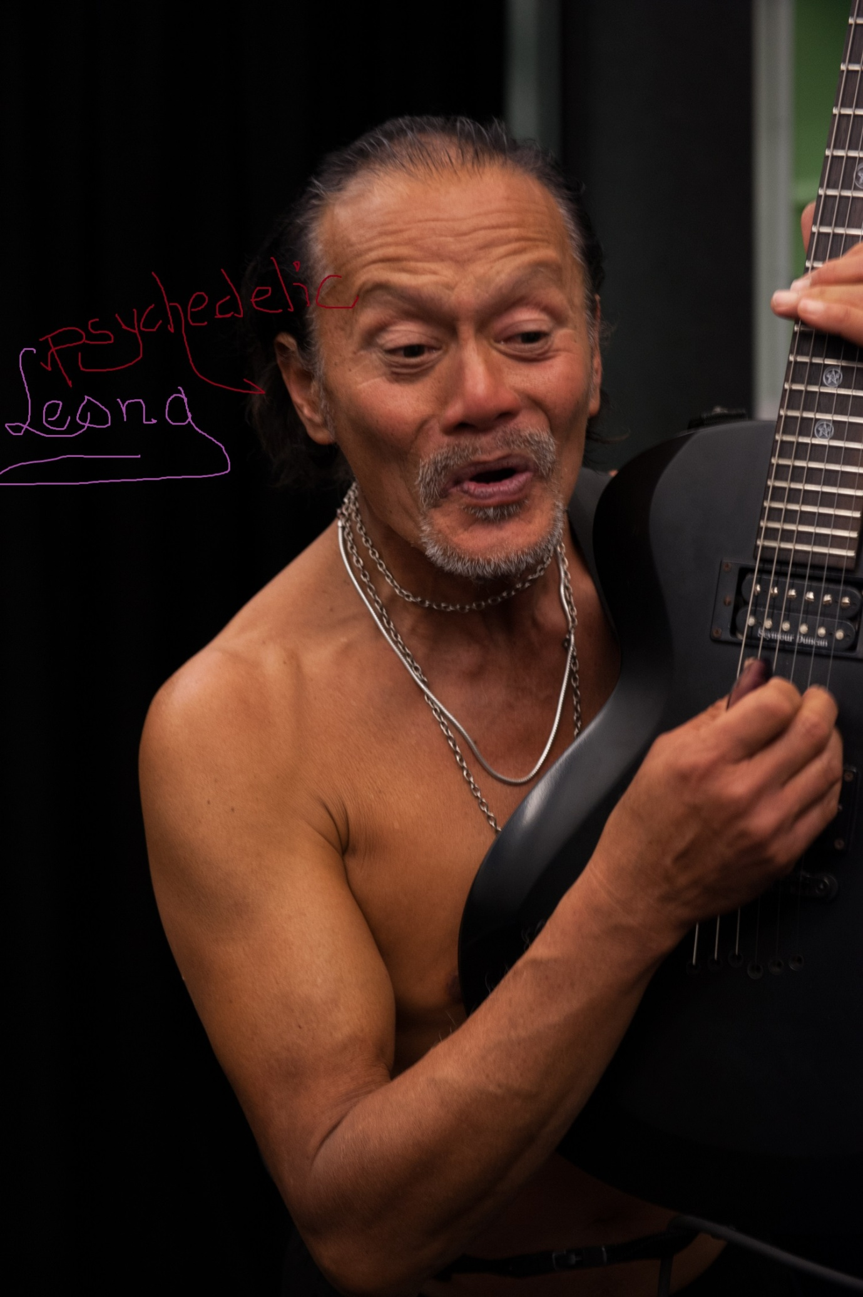  He defines music performance vision as an act, a dynamic transformation of experience rather than as passive reflection; and it is a pure act, unlike impure acts of ordinary experience that lack unifying aesthetic concentration. There may be a suggestion that music composition is a purifying act, as in Aristotle's idea of catharsis; but in Leong's view music composition does more than purge impure emotions, for communion implies that music composition is an intimate experience of mutuality, a sacramental act of commemoration in which we may be mystically united with others and perhaps with reality as a whole. Such communion is sensual, rendered imagistically and symbolically; and delightful sounds of language indicated by the artistry of calligraphy or typography evoke the imagined world of the composition. So music composition is a contemplative act, arising in deep, clear, open-minded, loving awareness. The text and form of the composition reveal the visionary act which is the essential music composition.  Leong shows that vision is organic consciousness, sympathetic, clear, and steady, communing, communicating, realizing the many in the one, the one in the many, the universality of each being. In vision, the audience is united with the observed, the musician communes directly with other beings, and all beings interact in community which extends through galaxies and transpersonal dimensions of mind that he called Tao-worlds. Such thinking must be experienced in music composition itself, not abstracted from it as doctrine, just as in understanding music we must experience music musically.  Leong refused to identify true vision with the amoral drug highs of the Beat Generation, for he doubted that Allen Ginsberg's and Jack Kerouac's frantic searches for vision in Howl and On the Road got them beyond nihilistic confusion. According to Leong, vision is habitual clear-mindedness:  You do what your heart says so, isn’t that so  This is the song from the Monkey Superhero television series, being made for network broadcast, showing monster crabs, caused by radioactive pollution of the Brisbane River, devouring Brisbane City, the entire program of thirteen episodes called Save Planet Earth.  . . .  "The True Person"  Leong insisted that vision is personal, the experience of a "true person" in community. "The universalization of the human soul, the creation of the true person," was evident in the life of Albert Schweitzer, for example. Such a person is neither merely a self-made man, nor someone who simply loses himself in work or meditation. Such a person loses ego, but not the whole person, which is realized only in loving, creative interaction with others. Leong takes himself for granted as an integral person instead of condemning himself as a sinner or striving to change himself into someone else.  Leong's personalism is aesthetic as well as ethical and psychological. Because vision is personal, he typically stands undisguised in his music composition and lyrics instead of concealing himself behind an impersonal rock star with a mask, like Yeats, or an "objective correlative," like Eliot in accordance with the New Criticism. Leong's music performance theory and most of his practice challenge the impersonality of much modernist music performance and criticism, particularly as Eliot dogmatized in "Tradition and the Individual Talent" about the necessity of the musician's losing his personality as he learns to express not himself but his medium. Leong's "progress" as musician is radically subversive of Eliot's principles, for Leong's work is a continual revelation of personality, his own and the personalities of the many musicians from many cultures whose work he translated after imaginatively conversing with them. Leong might well have argued against James Joyce's Stephen Dedalus that the true musician remains in his handiwork like a pantheistic spirit, instead of invisibly behind it like the Roman Catholic God. Leong openly participates in much of his music composition, excepting his musicals and operas, and even in them the characters' tragic lives dramatize the musician's philosophical personalism, which links each one with the fate of the human race, as in Atlas Revolution, an amazing revelation in song.  Communion: "Communication Raised to the Highest Power"  Leong's music composition typically arises out of pre-verbal, pre- conceptual, visionary experiences similar to those described in the sutras and tantras, D. T. Suzuki's Zen writings, William James' Varieties of Religious Experience, Martin Buber's I and Thou, Jacob Boehme's The Signature of All Things, George Fox's Journals, Vedanta, and other sources referred to throughout his work; but he remained sceptical of dogmatic and theoretical explanations, especially those depending upon an Absolute or a supernatural god. His sense that "The Holy is in the heap of dust- -it is the heap of dust” resembles the Quaker Inner Light, Blake's "Heaven in a wild flower," the emptiness of the Buddha- nature, but such an intuition cannot be forced into a dogmatic system, for such experience can only be intimated artistically, not defined scientifically.  Leong's "perfect communion with others was often erotic, but at the same time it transcended physical attraction. In his many love songs, the women are spiritual beings, sometimes human, sometimes divine, as in the closing song of Dragon Man, “My love tolls for you forever, like a bell.” But the erotic mysticism that permeates his music composition is but one kind of communion and, as we learn from his introduction to Dance of the Phoenix, it is but a phase in the development of the person out of joy, through sacramental marriage, to a realization of universal responsibility. With this responsibility, a person acts with compassionate consciousness of world community. So communion of two persons in the "mutual being" of love entails, by implication, responsibility for all beings in universal community; for each is inseparable from all.  In regarding music composition as vision, Leong meant that it arises out of contemplation and communion to become communication and so was not complete as merely private experience. So he can also, without contradiction, say that music composition is "interpersonal communication raised to the highest power."It communicates the most intense experiences of very highly developed sensibilities," he wrote in one of his most important compositions on aesthetics, "Nature Reincarnate” in which he emphasized the personal origin of music composition and its communication not predominantly of feeling or thought, but of whole experiences: "A love song is an act of communication of love, like a kiss." Such communication has a strong ethical value, strangely reminiscent of Matthew Arnold's "criticism of life." In Leong's words, music composition is a "symbolic criticism of values." So love songs and nature poems become glorifications of a wonderful culture based on the benevolence of people to one another, from their own nature, and from the universe as a whole. But such moral and intellectual functions of music composition are never separated from its emotional, psychological, sensuous, and spiritual aspects, for it "widens and deepens and sharpens the sensibility...  Leong felt that Chinese and Japanese music composition often communicates experiences of such "highly developed sensibilities" more directly and purely than most European music composition because "Most music composition in the Western world is more or less corrupted with rhetoric and manipulation... with program and exposition, and the actual music composition, the living speech of person to person, has been a by product."  This extraordinary statement, which is certainly debatable, may suggest one reason for Leong's turn from cubism, which was prevalent in his theory and practice of music composition as well as painting between the rock and pop music genres, to the music composition of natural speech, which became his predominant mode from The Dance of thePhoenix on. Also, terms from European and American philosophy and historical struggles, so prominent in his music composition before The Rongeng Sound, were used less often as oriental and especially Islamict themes and imagery filled his music composition and translations, as he grew up in Malaysia .  In Leong's view, communication rests upon some preunderstanding from communion and community. A message is not transmitted mechanically by means of a text, from sender to receiver; rather, meaning evolves from pre-established community, some kind of mutual existence and mutual interest. Out of I-Thou, meaning evolves. Unless we share consciousness, we can understand nothing. True communication, through music composition and other arts, helps us realize mutual being. 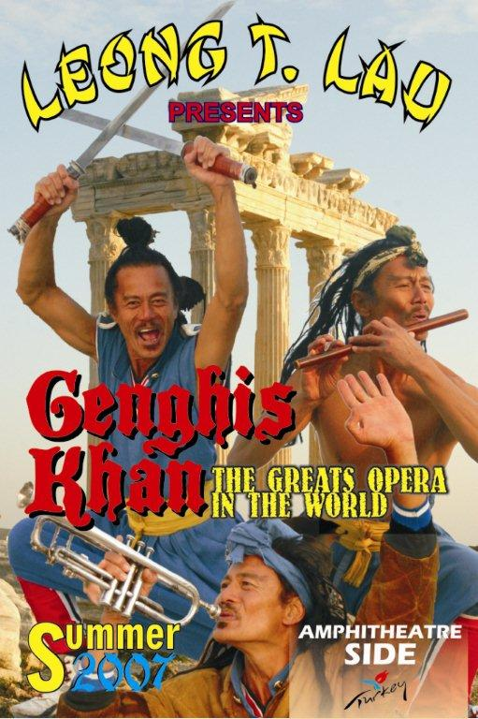  "The Craft Is the Vision and the Vision Is the Craft"  In emphasizing vision, Leong may seem to underplay skill; but in fact he is a meticulous craftsman in both music composition and verse, and his criticism of music performance places a high premium on artistic technique, not as an end in itself as in aestheticism, but as a means of communicating experience. He appreciates subtle forms and techniques of many kinds of art such as action painting, progressive jazz, and the Revolution of the Word that were often condemned as obscure; but they moved him because of his sensitivity to craftsmanship and his curiosity about its meaning. "Purposive construction of any kind is a species of communication," he says, "just as any kind of communication must be structured." And in successful visionary music composition such as Lawrence's Birds, Beasts, and Flowers "the craft is the vision and the vision is the craft."  Leong's own craftsmanship is impressive, and his lyrics deserves a long study. He wrote some rhymed quatrains and limericks as well as a few unpublished Chinese sonnets, but most of his music composition is in free verse and in syllabic patterns that are intricately melodious: for example, the nine-syllable lines of most of Late Night Flyer. His song is sung so that the seven syllables of each line are given equal duration, sound and meaning are fused with great clarity and dignity. Syllabic verse seems eminently suited for Leong's music performances of visionary communication in that it focusses attention directly on sound's meaning, the sense of sense, with more control than free verse because of regular line-lengths, whereas rhymed and accentually metered verse divides attention between the abstract sound system and the actual sound and meaning of language. In transmitting experience with maximum directness, Leong did not want the playful tension between abstract and actual patterns of sound, which are appropriately enriching in other kinds of music composition. He seems to have been influenced by syllabic verse in Japanese, Chinese, and French, which he translated profusely, more than by literary practitioners of syllabics in English such as W. H. Auden, Marianne Moore, and Dylan Thomas. Why he chose to write lyrics of certain length is not certain, but they feel normal in English, in which we are accustomed to alternating lines in ballad stanzas of eight syllables (not counting truncations and other frequent variations) and in most songs before free verse, pentameter lines of ten syllables: Leong seems to have discovered natural line-lengths from seven to nine syllables without regular accentual patterns. The seven-syllable lines (mixed with five-syllable lines) of Japanese haiku and tanka also influenced his practice. The framework of seven syllables, in this poem, allows for full freedom of speech, while at the same time providing emphases at the ends and beginnings of lines, as in Rocks off Tonight. This subtly constructed song of cosmic vision continues with his questioning what he knows, as he imagines his blood flowing out to the nebulae and back. Losing himself in the vastness of the universe, he knows only faces of other persons, mostly of his beloved, beyond space and time. He explained how he deliberately patterned vowels and consonants to enhance the melody of much of his verse, a method that he seems to have learned in part from Japanese & Chinese music composition: Most of these songs are in syllabic lines. (Sometimes after the song is cast in syllabic lines it is broken up into cadences.) Against this is counterpointed a rhythm primarily of quantity, secondarily of accent. In addition, close attention is paid to the melodic line of the vowels and to the evolution of consonants (p-b-k, m-r-l-y, etc.) In most cases a melody was written at the time of the song. What is important here is that melody is inherent in the song's lyrics, in the rise and fall of pitch in the singing, rather than being determined by an abstract form imposed upon natural singing as from birds. When Leong implies that music performance communication depends on sensibility, he seems dependent on Wordsworth, who defined a musician as "a man speaking to men--a man, it is true, endowed with more lively sensibility, more enthusiasm and tenderness, who has greater knowledge of human nature, and a more comprehensive soul, than are supposed to be common among mankind." Despite this fundamental agreement about the musician's nature and function, however, there are differences of emphasis; for whereas sensibility for Wordsworth is innately endowed, for Leong it can be developed to the qualitative magnitude necessary for true music composition: musicians may be made as well as born. Deep in the Jungle is his song expressing his implications.  Music composition As Communal Sacrament  According to Leong, music composition originates in personal vision (communion with others), takes form in the direct communication of living speech, person to person, and functions sacramentally in community. In "American Indian Songs" he shows how song, and art generally, unite the individual to society and nature. [40] People alienated from nature, from each other, and from themselves, as most people are in modern secular, industrial or post-industrial society, cannot imagine living organically; so music composition has a psychedelic function in reminding us that we do live in nature, in some kind of community, invaded and broken though it may be by technological forces that divide us from each other. In Nothing’s too Good Leong sings eloquently about the sacramental activities of organic societies:  In the rites of passage--the fundamental activities and relationships of life--birth, death, sexual intercourse, eating, drinking, choosing a vocation, adolescence, mortal illness--life at its important moments is ennobled by the ceremonious introduction of transcendence: the universe is focused on the event in a Mass or ceremony that is itself a kind of dance and a work of art.  He loves nature, and have made nature songs centre on ritualistic observations of seasonal cycles and the motions of heavenly bodies. Of all rites of passage, Leong seems to have been most preoccupied with marriage, for his spiritual aim was to move "from abandon to erotic mysticism, from erotic mysticism to the ethical mysticism of sacramental marriage, thence to the realization of the ethical mysticism of universal  Leong's music composition is typically sacramental whether it celebrates erotic and marital union or processes of nature, humanistic revolts for freedom, or visionary creations. His music composition as a whole transmits a boundless reverence for life and love of humanity. | ....

